

Rochester Institute of Technology

IST Lab Worker Training [beta]



Contents

1 Basics 4

1.1 Contacts 4

1.1.1 John Simonson 4

1.1.2 Anthony Critelli 4

1.1.3 The Current Graduate Assistant 4

1.2 Time Clock 4

1.3 Green Vests 4

1.4 Blue Vests 4

1.5 Lab Usability 4

1.6 The Work Portal 5

1.6.1 URL 5

1.6.2 What is this website 5

1.6.3 Task List 5

1.6.4 Notice Board 5

1.6.5 Employee Tools 5

1.6.6 Resources 6

1.7 Slack 6

1.7.1 What is Slack 6

1.7.2 Slack Team URL 6

1.8 Lost and Found 6

2 Inventory Check-out System 6

2.1 What is it 6

2.2 URL 6

2.3 Checkout 7

2.3.1 Typical 7

2.3.2 Future Everyday Technology (F.E.T.) Items 8

2.3.3 Second ID 8

2.3.4 Signature 9

2.4 Item Return 9

2.5 Adding Customers 10

3 Labs 10

3.1 Cleaning 10

3.1.1 Maintenance Tasks 10

3.2 Cleaning Tasks 10

3.3 Food / Drinks 11

3.3.1 Drinks 11

3.3.2 Food 11

3.3.3 What to Do 11

3.4 Lab Rooms 11

3.5 Open VS Classes Only 11

3.5.1 Open 11

3.5.2 Class Only 11

4 Opening / Closing 11

4.1 Door Locks 11

4.1.1 Unlock a Lab 11

4.1.2 Lock a Lab 12

4.1.3 Exceptions 12

4.2 Opening Tasks 12

4.3 Closing Tasks 12

5 Cage 12

5.1 What is the Cage 12

5.2 Cage Responsibilities 12

5.2.1 When Should I Be There 12

5.3 Not Found In Cage 12

5.4 Where is Everything in the Cage 13

6 The Archive 13

6.1 What is the Archive 13

7 Future Everyday Technology (F.E.T.) 13

7.1 Checking out F.E.T. Equipment 13

8 Mobile Devices 14

8.1 What Counts as a Mobile Device 14

8.2 Who Can Check Out Mobile Devices 14

9 Ghost 14

9.1 Imaging 14

9.1.1 Precautions 14

9.1.2 How to Image 14

9.1.3 How to Check on an Ongoing Image Process 17

10 Fluke 18

10.1 What is the fluke? 18

10.2 Wire Mapping 18

10.3 Cable Tracing 18

11 Training 19

11.1 Instructeds 19

11.2 Masteries 19

11.3 Categoricals 19

# Basics

## Contacts

### John Simonson

Office: GOL-2349  
Email: [jssics@rit.edu](mailto:jssics@rit.edu)   
Phone: 585-475-6051

### Anthony Critelli

Office: GOL-2351  
Email: [aacics@rit.edu](mailto:aacics@rit.edu)

Phone: 585-475-7931

### The Current Graduate Assistant

Office: GOL-3275

Email: Their Standard RIT Student Email

Phone: No RIT Phone Provided

## Time Clock

You must punch in and out and starting and ending your shift. This can either be done at a KRONOS clock or at the website <http://bill>. Please note that the online punching will only work in the labs and the cage. A KRONOS clock is located on the first floor to the left of the microwave. It is pictured below.

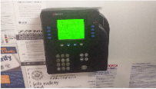

Figure 1 - Kronos Clock

## Green Vests

Green vests are required to be worn at all times while on the clock. It allows everyone to know who is currently working in the labs.

## Blue Vests

Blue vests are to be worn by teaching assistants. At times you will see TA’s come in to get their vests. This is to let students know they can come to them for help.

## Lab Usability

Once per hour, at the 15 minutes past mark, we take a count of how many people are using each lab. These numbers are recorded per lab in a google docs sheet with your initials. You can find it linked on <https://work.cias.rit.edu/ist/> under the Resources Tab labeled as Usability. You can find more information about the work portal in section https://work.cias.rit.edu/ist/

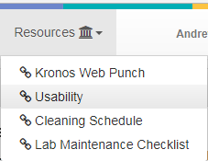

Figure 2 - Usability Link in Work Portal

For example, if you shift is from noon till 4 you would take usability at 12:15pm, 1:15pm, 2:15pm, and 3:15pm. The next shift would take their first usability at 4:15pm.

## The Work Portal

### URL

#### Universal URL

<https://work.cias.rit.edu/ist/>

#### Lab CNAME

<http://work/>

### What is this website

This website is where you list your availability and can see your schedule. It has links to useful resources and where lab tasks are posted.

### Task List

The Task List is all things that currently need to be performed. Some repeat on an interval such as checking the lab inventory or facility maintenance. It is your reasonability when on shift to check these tasks, complete them, and mark them as complete.

### Notice Board

This is an electronic notice board. Items that have come up that you need to be made aware of are posted here.

### Employee Tools

This is a collection of tools relating to employees and their schedules.

#### Do Self Review

This is a feature of the Work portal that we do not current utilize.

#### List My Self Review

This lists all your self-reviews. However, since we do not use the self-review feature of the Work Portal, there should not be any listed.

#### Lab Assistant Schedule

This shows every Lab Assistant’s schedule. You can use this to see who is working when.

#### Teaching Assistant Schedule

This shows every Teaching Assistant’s schedule. You can use this to see who is working when.

#### Shift Coverage

Once the final schedule is posted for the semester, employees are responsible for finding a replacement for their shift if time off is desired. If you need to get your shift covered or are looking to cover someone else’s shift, use the Shift Coverage page. Remember, if no one takes your shift then you are still responsible for it!

#### Missed Punch

It is your responsibility to review your timecard for missing or incorrect punches. Employees should check their timecards when payroll is due; even if they believe, they have not missed any punches. Use the missed punch tool to send punch corrections. The following URL can be used to check your timecard.

<https://fastapps.rit.edu/kronosTimecard>

### Resources

#### Kronos Web Punch

This is a link to the online time clock to punch in or out. You can only use this when inside the labs.

#### Usability

This is a link to the Google Doc where we record usability.

#### Cleaning Schedule

This link to the Google Doc, which contains is assigned as the primary contact for each lab. Although everyone is responsible to clean all the labs, the primary contact for a lab must maintain that his or her lab is clean and tidy.

## Slack

### What is Slack

Slack is an online instant messenger. We use it for quick communications. When on shift you are to be logged into Slack so that the IST Administrators may contact you. Remember that your correspondence in Slack should remain professional.

### Slack Team URL

Our Slack team URL is “*gccis.slack.com*”.

## Lost and Found

Anything that appears to have been forgotten by someone in the labs is to be placed in the lost and found box in the cage. The lost and found box should be taken to the Dean’s Office at least once a week preferably by Thursday or Friday afternoon.

# Inventory Check-out System

## What is it

An online system created in-house to manage all the items at students may check out. It ensures that the IST department knows exactly who has checked out any piece of equipment and whom to hold responsible for any damage that may occur while the item is out.

## URL

The URL you should use to open the Inventory System is <http://inventory/>. If this CNAME is not resolving, try the FQDN at <http://inventory.istlabs.rit.edu>.

## Checkout

### Typical

1. Customer requests an item
2. Verify the customer has authorization to check out the requested item. Currently only mobile devices and F.E.T. items have restrictions. Check the Mobile Devices and Future Everyday Technology (F.E.T.) sections for more information.
3. Scan / Swipe the customer’s RIT ID 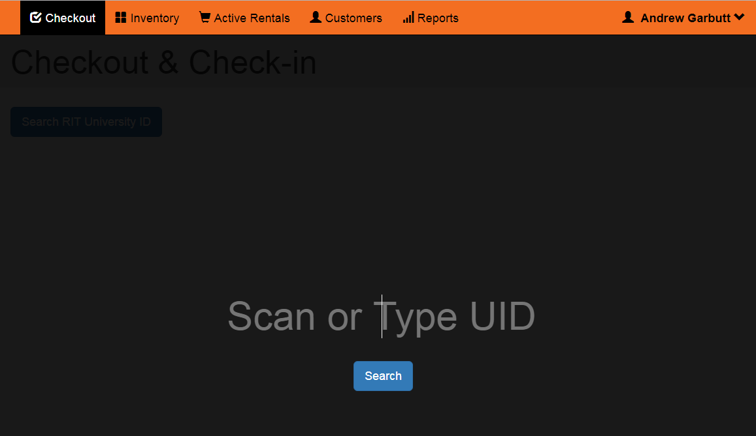

Figure 3 - Scanning RIT Card

1. If the customer does not exist, you will be prompted to add it. Check the Adding Customers section for more information.
2. If the customer is a student, place their ID with the others to be returned when the customer has returned all items. If the customer is faculty/staff, then return the ID to the customer.
3. Scan the requested item(s) the customer requested
   1. The focus will auto change to appropriate field  
      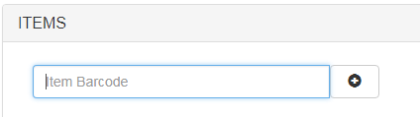

Figure 4 - Barcode Entry Field

* 1. If the item will not scan you can manually type out the barcode number. If the barcode number is not fully legible then you can browse inventory for the item to obtain the appropriate barcode

1. The cage carries frequently checked out items. If more than what is available in the cage is needed, check the Archive (GOL-2340) AKA “The Arc” for extras. See the Archive section for more information about “The Arc”.

### Future Everyday Technology (F.E.T.) Items

F.E.T items are only for students taking Professor Ashbrook’s course in the F.E.T. Lab. For detailed information, see the Future Everyday Technology (F.E.T.) section. The basics which you need to know are:

* 1. Only check out to students on the approved list
  2. All items are for long term check out
  3. We do not collect IDs for F.E.T. items.

### Second ID

If the item requires a second ID then in addition to the Student’s RIT ID you must also take in a government issued ID. Same rule as RIT IDs, we do not collect faculty IDs at all. You can tell a Second ID is required by the 2nd ID field being filed out. In the example below, the Extreme Summit switch required a 2nd ID but the Linksys Router did not.

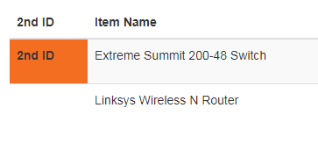

Figure 5 - Second ID Required Example

### Signature

1. If a signature is required, a modal will automatically appear. Show this to the user so that they may read it.

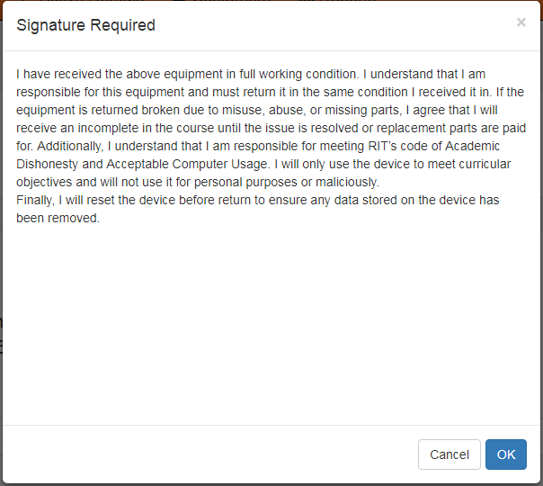

Figure 6 - Signature Modal

1. Present the Signature Pad for the user to sign. They must sign before clicking OK.

## Item Return

1. Customer hands item(s) to be returned to Lab Assistant
2. Lab Assistant checks item for damage
   1. If the item appears to have been damaged while it was out, notify a Lab Manager
3. If item is a Mobile Device, Lab Assistant checks that all accounts have been signed out of and the device is factory reset.
4. Lab Assistant scans customer’s RIT ID card just as you do when checking an item out.
5. Lab Assistant checks in appropriate item by clicking the “check in button”.

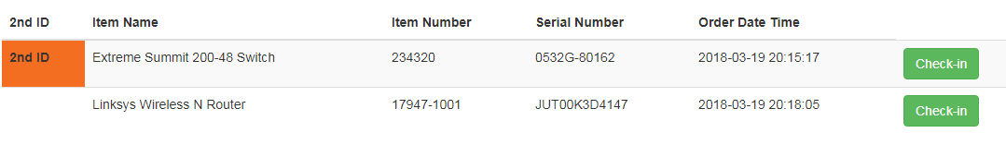

Figure 7 - Check-in Button to Left of Item

1. Return ID Card
   1. If the user has no more items checked out, return ID card
   2. If the customer has no more second ID equipment, return the customer’s second ID
   3. If the user has more equipment, keep the ID card until all equipment is returned

## Adding Customers

Scan the Customer’s ID as you normally would for checkout. If the customer does not exist, this will be detected and you will automatically be presented with the Add New User form. Fill out the Information and click Add User.

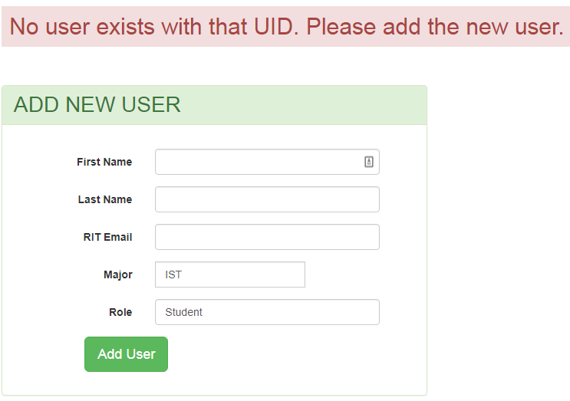

Figure 8 - Add New User Form

# Labs

## Cleaning

### Maintenance Tasks

* All computers are functioning normally
* Networking equipment is functioning normally
* Wall clock is displaying the correct time
* Chairs are in good working order and the correct height

## Cleaning Tasks

* Monitors are cleaned
* Dust the desks and towers
* Keyboards and mice are sanitized
* Floor is cleaned of debris and vacuumed
* Chair legs are clean
* White board is clean

## Food / Drinks

### Drinks

Drinks are allowed in the labs only if the container has a cover and it is not being left open.

### Food

No food in the labs at all, no exceptions. Even if it is in a bag or container, there is no food in the labs. This is both for cleanliness and food allergies.

### What to Do

If you see someone eating in the labs, kindly, politely, and firmly ask them to step outside.

## Lab Rooms

|  |  |  |  |
| --- | --- | --- | --- |
| Lab Name | Room Number | Classes Only / Open | Notes |
| Airgap Lab | GOL-2130 | Open | No Internet Access |
| Networking Lab | GOL-2160 | Open |  |
| Systems Administration Lab | GOL-2320 | Open |  |
| Large DB | GOL-2650 | Classes Only |  |
| Medium DB | GOL-2620 | Classes Only |  |
| Small DB | GOL-2520 | Classes Only |  |
| Mac Lab 1 | GOL-3510 | Classes Only |  |
| Mac Lab 2 | GOL-3690 | Classes Only |  |
| Security Lab | GOL-2410 | Open | Closes at Midnight; Swipe Access CSEC Students |
| Open Lab | GOL-2660 | Open | Open 24/7; Swipe Access GCCIS Members |
| Grad Lab | GOL-2670 | Open | Open 24/7; Swipe Access GCCIS Grad Students |

## Open VS Classes Only

### Open

Labs which are marked as open are labs that we open and close for students to come and use when they please throughout the day. These labs will sometimes have classes in them. The schedule for classes are located on each of the lab displays located near the lab doors or found at <http://www.istlabs.rit.edu/>.

### Class Only

These labs are opened and closed by the professors. They are only to be used by the professors to teach their courses.

# Opening / Closing

## Door Locks

### Unlock a Lab

1. Swipe RIT ID card
2. Enter 5 Digit pin number, then press “#”
   1. This is different from your KRONOS punch in number
3. Light will go from red to green – door will unlock

### Lock a Lab

1. Swipe RIT ID card
2. Enter your 5 digit pin number then press “#”
   1. This is different from your KRONOS punch in number
3. You should hear some beeps
4. Then punch in * 5 #
5. Light should go from green to red – door will lock

### Exceptions

The third floor Mac labs require the first 4 digits of your pin number instead of the standard 5 digit pin number, and do not need the ‘#’ sign after your PIN.

## Opening Tasks

1. Unlock labs that are marked open in the Lab Rooms Table unless the note indicates otherwise.
2. Ensure there was no trash missed by the person who closed the lab
3. Turn on networking equipment to ensure that the lab is ready for classes

## Closing Tasks

1. Notify students 10 minutes before closing (and do a usability head-count)
2. Ensure there is no trash in any of the labs
3. Turn off all networking equipment
4. Push in all chairs
5. Straighten up all keyboards, mice, and monitors
6. Turn off all lights
7. Lock all labs

# Cage

## What is the Cage

The Equipment Cage (GOL-2140) is where students come to check out equipment. It is where 99% of equipment checked out to students is stored.

## Cage Responsibilities

### When Should I Be There

There should always be a Lab Assistant ready to check out equipment in the cage. There are times when you may have to leave the cage when you are the only Lab Assistant in the Cage. When you leave the Cage empty you must lock the cage and write on the whiteboard where students can find you if they need to check something out. See Opening and Closing for more information about how to lock and unlock the Cage.

## Not Found In Cage

A Lab Assistant can always check “The Arc” if an item is not found in the Cage. See the Archive section for more information about “The Arc”.

The equipment cage is where 99% of equipment checked out to students are stored. There are a few infrequently used items or extra inventory located in “The Arc”. If you notice that you are frequently needing to check for more inventory, notify an IST System Administrator so that the need for more inventory is known. Otherwise, we won’t know that the Cage is not providing the needs of the students.

## Where is Everything in the Cage

Below you will find a basic map of most things in the cage. This will change often because old equipment is retired, new equipment is acquired, and course requirements can change. Therefore, this map may be out of date. However, related items are generally kept together. This means routers and switches of various brands will generally be near each other. Please refer to seasoned labbie if something is not where it is listed here as its home location may have changed since the last update.

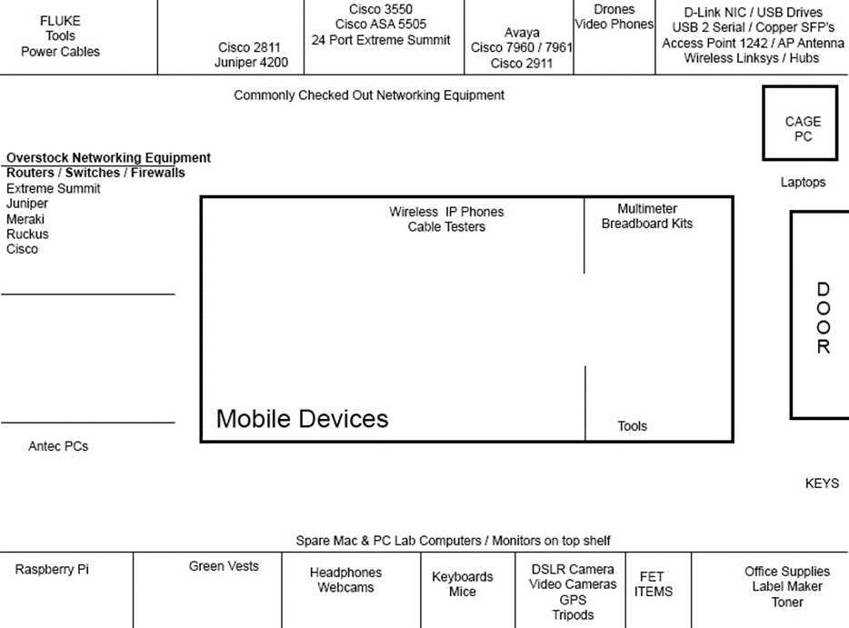

Figure 9 - Map of Cage Items

# The Archive

## What is the Archive

The Archive (GOL-2340) is more commonly referred to as “The Arc”. While the cage holds 99% of what a Lab Assistant will need, The Arc holds the rest. When an item is not found in the cage, a Lab Assistant can check The Arc for it.

# Future Everyday Technology (F.E.T.)

## Checking out F.E.T. Equipment

All F.E.T equipment is checked out for an entire semester but some students might return an item sooner. Some are consumed when used which means that we do not expect it to return. We still need to check it out to the student to keep a record of what is being used. We have a printed set of pages of everything we have for the F.E.T. Lab to hand to students to help identify the part which they are requesting. These pages are stapled together and kept with the F.E.T. equipment. All F.E.T. Equipment is located together is the Cage.

# Mobile Devices

## What Counts as a Mobile Device

A mobile device are devices such as tablets, phones, or iPods.

## Who Can Check Out Mobile Devices

Anyone can check out a mobile device for same day return but only students of specific classes can check them out for an entire semester. These students are printed on a paper above the checkout machine.

# Ghost

## Imaging

### Precautions

1. Make sure no one is using the computer or lab you are about image
2. Never image every computer at one time. Imaging too many computers will strain the server to the point where it will take much too long to image and could cause errors.
3. Only image half of a lab at a time to ensure even if something goes wrong, a lab has at least half of its computers.
4. Primarily imaging will be performed at night or after a closed lab has no further classes for the day.

### How to Image

1. Open the Deployment Console on a Cage computer

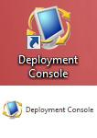

Figure 10 - Deployment Console Icon

1. Once open, you will be in the Ghost Solution Suite or Ghost for short. From there, you can find all of the computers that are managed by the IST labs on the left panel under Computers > All Computers sorted by the lab in which they are physically located.

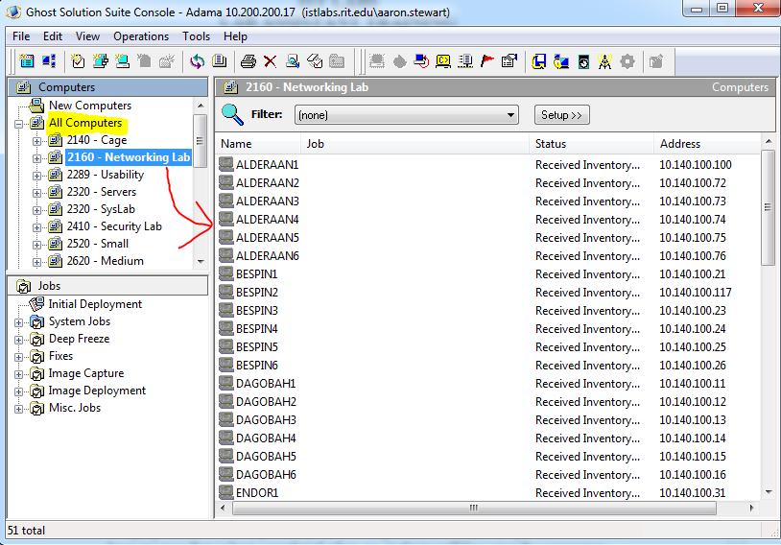

Figure 11 - Ghost Main Interface

1. Once the desired computer(s) is selected, you can then click and drag it to the desired image to deploy Jobs > Image Deployment > Deploy Windows Image – CURRENT IMAGE

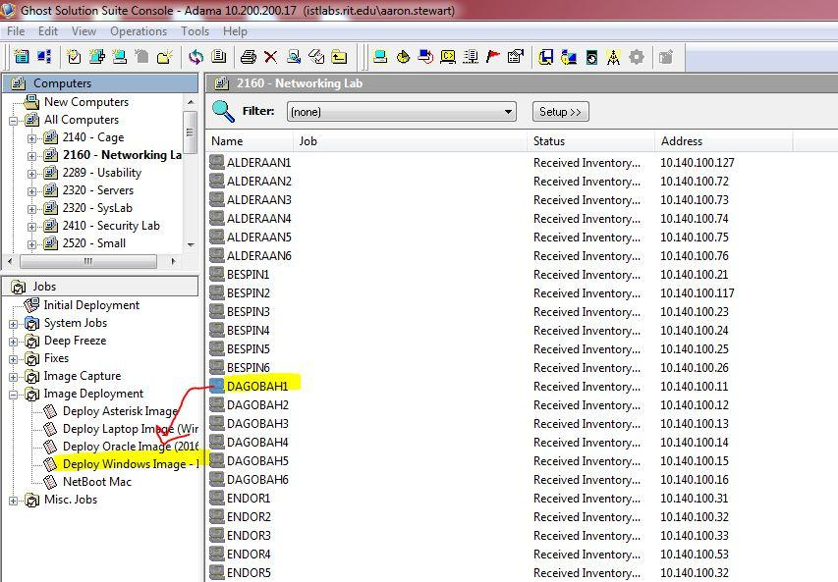

Figure 12 - Deploying Windows Image

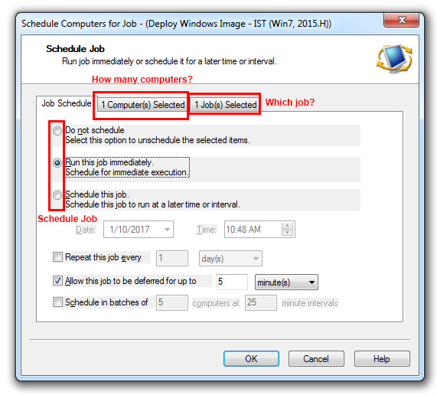

Figure 13 - Deploy Image Scheduler

1. The Schedule Job window will appear. In it Lab Assistants can then either run this job immediately or schedule this job for a specific date and time.
2. Review the Schedule Computer for Job dialog box to carefully review how many computers, which jobs, and when the job is scheduled for.

### How to Check on an Ongoing Image Process

The progress of the imaging can be checked under the Jobs > Image Deployment > Deploy Windows Image – CURRENT IMAGE screen

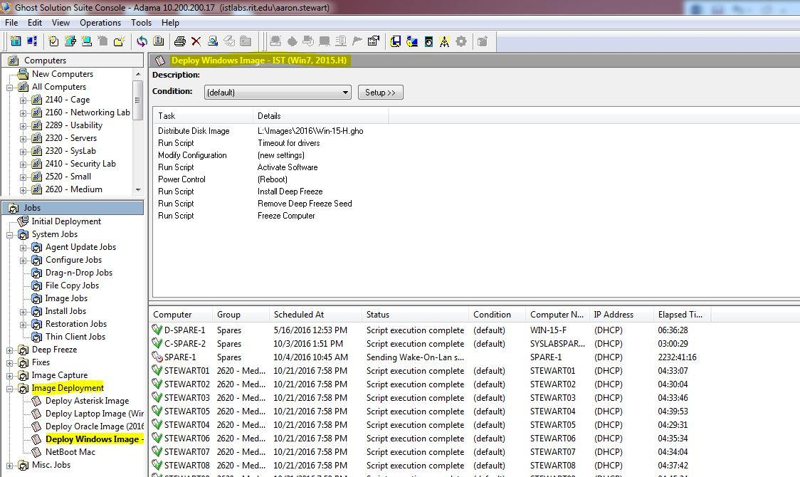

Figure 14 - Checking on Ongoing Process

# Fluke

## What is the fluke?

The fluke is a very expensive piece of equipment used to check cabling. It is commonly used to check wire mapping and to trace cables when physically doing so is not feasible. It may also be used for more advanced testing such as interference testing. Do not leave it unattended!

## Wire Mapping

1. Turn both Fluke Devices on
2. Attach network adapters to Fluke Devices to give them either male or female Ethernet adapters
3. Plug Fluke Devices into the cable you wish to test
4. Press Test on the main fluke device
5. It may warn you that it is not compatible with the selected test limit, Press F3 for okay
6. The wire mapping test will begin

## Cable Tracing

1. Plug the screen-less Fluke Device into a known end of the cable
2. Press test on the Fluke Device with the screen
3. Plug the Fluke Device with the screen into where you think the other end of the cable is
4. If it finds the other Fluke Device it will make a noise and indicate it on the screen
5. If it does not, then either the cable is completely severed or that was not the proper end and you need to start again at step 3
6. You should now perform a wire mapping test because it only takes a moment and can reveal issues before they become huge problems

# Training

## Instructeds

Any fully trained lab assistant may instruct a trainee. Instructions are to include any information needed for the relevant skill. The full lab assistant should reference the training documentation to ensure completeness in the instruction. After giving an instruction, the full lab assistant is to sign their name and date in the box provided.

## Masteries

After a week has passed, a trainee can attempt a mastery. A mastery may only be completed by a senior lab assistant or higher and cannot be the same person who gave the instructed. The purpose of a mastery is for the trainee to prove that they have mastered that skill. Masteries can include the senior+ asking questions or for demonstrations. It is up to the discretion of the senior+ as to when a person has mastered a skill. Once completed the senior+ writes his initials and the date in the box provided. This is to represent that that senior+ could vouch for that trainee that the trainee has mastered the skill.

## Categoricals

Categoricals may only be attempted once all of the masteries in a category has been completed. Categoricals may only be signed off by a Graduate Assistant and above but if that person gave the majority of masteries for a category, then that person may not sign off on that categorical. Categoricals are similar to masteries however, they encompass the entire category and tend to include more difficult questions. The signoff goes into the Mastered column but in the Category’s Row. There are no instructeds for categories.

Name:________________________________________________________ Date Issued:________________

|  |  |  |
| --- | --- | --- |
| Category | Instructed | Mastered |
| *Basics* |  |  |
| Contacts |  |  |
| Time Clock |  |  |
| Green Vests |  |  |
| Blue Vests |  |  |
| Lab Usability |  |  |
| The Work Portal |  |  |
| Slack |  |  |
| Lost and Found |  |  |
|  |  |  |
| *Inventory System* |  |  |
| What is it |  |  |
| Adding Users |  |  |
| Checkout |  |  |
| Item Return |  |  |
|  |  |  |
| *Labs* |  |  |
| Cleaning |  |  |
| Food / Drinks |  |  |
| Rooms |  |  |
| Open VS Classes Only |  |  |
|  |  |  |
| *Opening / Closing* |  |  |
| Door Locks |  |  |
| Opening Tasks |  |  |
| Closing Tasks |  |  |
|  |  |  |
| *Cage* |  |  |
| *What is the Cage* |  |  |
| Cage Responsibilities |  |  |
| Not Found In Cage |  |  |
| Where is Everything |  |  |
|  |  |  |
| *The Archive* |  |  |
| What is The Archive |  |  |
|  |  |  |
| *F.E.T. Lab* |  |  |
| Checking out F.E.T Items |  |  |
|  |  |  |
| *Ghost* |  |  |
| Imaging |  |  |
| *Fluke* |  |  |
| What is the Fluke |  |  |
| Wire Mapping |  |  |